AI-Powered Voice Assistant for Faculty Information and Timetable Retrieval

Project Documentation:
Submitted By:
Student Name: BHASHITHA CHENNU
Roll Number: 248T1A4204

Department: Computer Science and Engineering (AIML)

College: DHANEKULA INSTITUTE OF ENGINEERING AND TECHNOLOGY

Mentor:

Academic Year: 2025-2026

CHAPTER 1
PROJECT OVERVIEW

1.1 Introduction
The AI-Powered Voice Assistant for Faculty Information and Timetable Retrieval is a voice-enabled academic assistant developed to simplify the process of accessing faculty and timetable information within a college environment.
Instead of manually searching through faculty records or timetable documents, users can interact with the system using natural voice commands. The assistant converts the spoken query into text, understands the user's intention, retrieves the required information from the database, generates an appropriate response, and finally speaks the answer back to the user.
The project combines modern Artificial Intelligence techniques with database retrieval to provide a fast and user-friendly solution for accessing academic information.
The system supports multiple categories of queries related to faculty profiles and class timetables while maintaining a modular architecture that allows future enhancements.

1.2 Problem Statement
Faculty and timetable information in many educational institutions is usually stored in spreadsheets, printed documents, or institutional portals. Retrieving specific information often requires manual searching, making the process time-consuming and inconvenient.
Examples include:
- Finding a faculty member's qualification.
- Checking faculty experience.
- Viewing section timetables.
- Identifying the first or last class of a section.
- Finding the class scheduled at a specific time.
- Determining vacant classrooms.
Performing these tasks manually is inefficient, especially when users need quick access through voice interaction.
The objective of this project is to automate this process using an AI-powered voice assistant capable of understanding natural language queries and retrieving accurate information from the institutional database
1.3 Need for the Project
The project was developed to address the following requirements:
- Provide quick access to faculty information through voice commands.
- Reduce the time required to search timetable information manually.
- Improve accessibility by enabling hands-free interaction.
- Demonstrate the integration of Speech Recognition, Large Language Models, and Database Retrieval within a single application.
- Create a modular system that can be expanded with additional academic services in the future.

1.4 Scope of the Project
The current implementation focuses on providing voice-assisted access to structured academic information.
The system currently supports:
Faculty Information
- Faculty Profile
- Faculty Qualification
- Faculty Designation
- Faculty Experience
- Faculty Date of Joining

Timetable Services
- Complete Section Timetable
- Day Timetable
- Current Class
- Next Class
- First Class
- Last Class
- Class by Time
- Faculty Subject Lookup
- Vacant Room Identification

Voice Features
- Speech-to-Text Conversion
- Natural Language Understanding
- AI Response Generation
- Text-to-Speech Output
1.5 Project Features
The developed system provides the following features:
- Voice-based interaction.
- Offline speech recognition using Whisper.
- Automatic query classification.
- Service-based routing.
- Faculty information retrieval.
- Timetable retrieval.
- AI-generated natural language responses.
- Voice output using Text-to-Speech.
- PostgreSQL-based structured data retrieval.
- Modular Python implementation.
- Easy extensibility for future development.

1.6 Project Workflow Overview
The overall workflow of the system is given below:

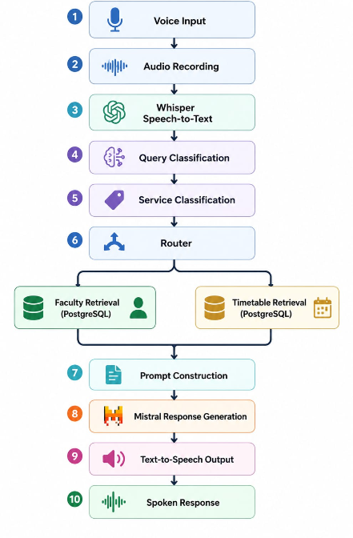
CHAPTER 2
TECHNOLOGIES USED
The development of the AI-Powered Voice Assistant for Faculty Information and Timetable Retrieval required the integration of multiple software technologies, machine learning models, databases, and Python libraries. Each technology was selected based on its suitability for voice processing, natural language understanding, database retrieval, and response generation.

2.1 Python
Purpose
Python is the primary programming language used for developing the entire project.
Why Python?
Python provides a rich ecosystem of libraries for Artificial Intelligence, Speech Processing, Database Connectivity, and Natural Language Processing. It also allows rapid development through its simple syntax and modular programming capabilities.
Usage in the Project
Python is used for:
- Voice recording
- Speech-to-text conversion
- Query processing
- Query classification
- Service classification
- Routing
- Database retrieval
- Prompt generation
- Communication with Mistral through Ollama
- Text-to-Speech conversion
- Overall system integration
Advantages
- Easy to learn and implement
- Large collection of AI libraries
- Platform independent

2.2 Visual Studio Code (VS Code)
Purpose
Visual Studio Code was used as the Integrated Development Environment (IDE) for writing, testing, and debugging the project.
Why VS Code?
VS Code provides several features that improve development efficiency.
Usage in the Project
- Writing Python source code
- Debugging modules
- Managing project files
- Running terminal commands
- Virtual environment management

2.3 PostgreSQL
Purpose
PostgreSQL is used as the primary database for storing faculty and timetable information.
Why PostgreSQL?
Initially, CSV files were used to store project data. As the project expanded, PostgreSQL was adopted because it provides faster querying, better scalability, and structured data management.
Usage in the Project
The database stores:
- Faculty profiles
- Complete timetable information
The router retrieves the required information using SQL queries before passing the result to the answer generation module.
Advantages:
- Supports complex SQL queries
- Easy integration with Python
- Suitable for structured academic data

2.4 Whisper
Purpose
Whisper is used for converting spoken audio into text.
Why Whisper?
The project required an offline speech recognition model capable of understanding natural English speech without relying on cloud services.
The Whisper “Small” model was selected because it provides a good balance between recognition accuracy and execution speed.
Usage in the Project
Whisper performs the following tasks:
- Receives recorded audio.
- Processes the audio file.
- Converts speech into text.
- Sends the recognized text to the query classifier.
Advantages:
- Offline speech recognition
- High recognition accuracy
- Supports natural language queries

2.5 Ollama
Purpose
Ollama is used to execute Large Language Models locally.
Why Ollama?
Instead of depending on online APIs, Ollama allows local execution of open-source language models, ensuring privacy and offline availability.
Usage in the Project
Ollama is responsible for:
- Running the Mistral language model
- Receiving prompts from Python
- Generating natural language responses
Advantages:
- Local execution
- Easy API integration
- Fast model management

2.6 Mistral Large Language Model
Purpose
Mistral is used to generate human-readable responses from the retrieved database information.
Why Mistral?
The retrieved database information is often structured and not suitable for direct presentation to the user. Mistral converts this structured information into clear and natural English responses.
Usage in the Project
Mistral receives:
- User query
- Result type
- Retrieved information
It generates:
- Faculty information responses
- Timetable responses
- Error messages
Strict prompting is used to ensure that the model answers only from the retrieved information.
Advantages:
- Natural language generation
- Easy integration through Ollama
- Offline execution

2.7 Sentence Transformers
Purpose
Sentence Transformers were explored during the Retrieval-Augmented Generation (RAG) implementation.
Why Sentence Transformers?
They convert textual information into vector embeddings, enabling semantic similarity search.
Usage in the Project
Sentence embeddings were generated for:
- Faculty information
- Timetable records

These embeddings were indexed for semantic retrieval during the RAG implementation.
Although the current implementation primarily relies on PostgreSQL for structured retrieval, Sentence Transformers remain an important component of the RAG workflow explored during development.
2.8 Chroma DB
Purpose
Chroma DB was investigated as the vector database during the initial RAG implementation.
Why Chroma DB?
It stores vector embeddings and enables efficient similarity-based retrieval.
Usage in the Project
Chroma DB was used to:
- Store faculty embeddings
- Store timetable embeddings
- Retrieve relevant documents based on semantic similarity

During development, PostgreSQL retrieval proved more suitable for structured timetable queries. Therefore, PostgreSQL became the primary retrieval mechanism while Chroma DB remains part of the RAG exploration.
Advantages:
- Fast vector search
- Easy Python integration
- Supports semantic retrieval

2.9 Pandas
Purpose
Pandas was used for handling CSV datasets during the initial stages of the project.
Usage
- Reading CSV files
- Data preprocessing
- Data cleaning
- Data verification
- Importing records into PostgreSQL

2.10 Sound Device
Purpose
The Sound Device library records the user's voice through the microphone.
Usage
- Starts recording when the user presses the designated key.
- Stops recording when recording ends.
- Saves the recorded audio for speech recognition.

2.11 Text-to-Speech Library (pyttsx3)
Purpose
The Text-to-Speech module converts generated text into spoken audio.
Why pyttsx3?
The project required an offline speech synthesis engine.
Usage
- Receives the final response.
- Converts the response into speech.
- Speaks the answer to the user.
Additional formatting was implemented to improve pronunciation of technical abbreviations such as:
- Ph. D
- B. Tech
- M. Tech
- MCA
- M. Sc
- IoT
- EEE
- CSE

2.12 CSV Datasets
Purpose
CSV files were used during the early stages of development before migrating the data into PostgreSQL.
Datasets Used
- faculty_data.csv
- time_table.csv
These datasets contained the original faculty and timetable records that were later imported into the database.

2.13 Summary of Technologies Used
Technology | Purpose
Python | Core application development
VS Code | Development environment
PostgreSQL | Structured data storage and retrieval
Whisper | Speech-to-text conversion
Ollama | Local LLM execution
Mistral | Natural language response generation
Sentence Transformers | Embedding generation (RAG exploration)
Chroma DB | Vector database (RAG exploration)
Pandas | CSV handling and preprocessing
Sound Device | Audio recording
pyttsx3 | Text-to-speech conversion
CSV Files | Initial dataset storage

CHAPTER 3
SOFTWARE AND HARDWARE REQUIREMENTS
3.1 Software Requirements
Software | Purpose
Windows 13 | Operating System
Python 3.10+ | Project Development
Visual Studio Code | Code Editor
PostgreSQL | Faculty and Timetable Database
Ollama | Running Mistral LLM
Whisper | Speech-to-Text
Python Libraries Used
- whisper
- sound device
- SciPy
- requests
- psycopg2
- pyttsx3
- pandas
- sentence-transformers (used during RAG implementation)
- chromadb (used during RAG implementation)

3.2 Hardware Requirements
Component | Specification
Processor | Intel i5 or above
RAM | Minimum 8 GB
Storage | 10 GB Free Space
Microphone | Required for Voice Input
Speaker | Required for Voice Output

CHAPTER 4
PROJECT ARCHITECTURE
The project follows a modular architecture where each module performs a specific task. The output of one module becomes the input to the next module.
Figure 4.1: Overall System Architecture:

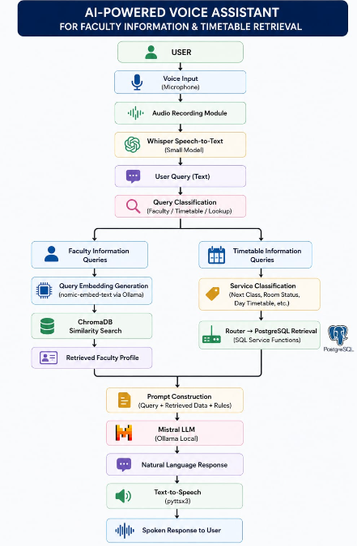

Figure 4.2: Knowledge Base Preparation (Faculty RAG):

Faculty CSV Dataset
│
▼
Data Cleaning & Formatting
│
▼
Embedding Generation
(nomic-embed-text)
│
▼
Vector Embeddings
│
▼
Chroma DB
(Vector Database)
Figure 4.3: Faculty Information Retrieval (RAG Pipeline)
Faculty Voice Query
│
▼
Whisper STT
│
▼
Query Classifier
│
▼
Generate Query Embedding
│
▼
Chroma DB Similarity Search
│
▼
Most Relevant Faculty Profile
│
▼
Prompt Construction
│
▼
Mistral LLM
│
▼
Faculty Information
│
▼
pyttsx3
│
▼
Voice Response

Figure 4.4: Timetable Retrieval Pipeline

Timetable Voice Query
│
▼
Whisper STT
│
▼
Query Classifier
│
▼
Service Classifier
│
▼
Router
│
▼
PostgreSQL Retrieval Function

┌─────────────────────────────────────┐
│ Day Timetable │
│ Section Timetable │
│ Faculty Timetable │
│ Current Class │
│ Next Class │
│ First Class │
│ Last Class │
│ Room Status │
│ Class By Time │
└─────────────────────────────────────┘
│
▼
Retrieved Timetable Data
│
▼
Prompt Construction
│
▼
Mistral LLM
│
▼
Natural Language Response
│
▼
pyttsx3
│
▼
Voice Response

Module Description:
4.3.1 Voice Input Module
Purpose
The Voice Input Module captures the user's spoken query through the system microphone. It serves as the entry point of the application and initiates the voice interaction process.
Working
- Activates the microphone and records the user's speech.
- Stores the recorded audio temporarily in WAV format.
- Passes the recorded audio to the Speech-to-Text module for transcription.
Input:
- User's voice.
Output:
- Recorded audio file.

4.3.2 Speech-to-Text Module
Technology Used
- OpenAI Whisper (Small Model)
Purpose
This module converts the recorded speech into text so that it can be processed by the chatbot.
- Accepts the recorded audio file.
- Uses the Whisper Small model to transcribe speech into text.
- Produces a text query for further processing.
Input:
- Recorded audio.
Output:
- User query in text format.

4.3.3 Query Classification Module
Purpose
The Query Classification Module determines the type of query submitted by the user and routes it to the appropriate retrieval pipeline.

The module classifies queries into different categories such as:
- Faculty Information
- Timetable Information
- General Lookup
For timetable-related queries, it also identifies the required timetable service (such as Next Class, Room Status, Section timetable, vacant room, Day Timetable).
Input
- User query in text format.
Output
- Query category.
- Service category:
Query |  |  |  | Service
Current class |  |  |  | CURRENT_CLASS
Next class |  |  |  | NEXT_CLASS
Monday timetable |  |  |  | DAY_TIMETABLE
Section timetable |  |  |  | SECTION_TIMETABLE
Vacant rooms |  |  |  | VACANT_ROOMS
Class at 10:50 |  |  |  | CLASS_BY_TIME

4.3.4 Faculty Retrieval Module (RAG Pipeline)
Purpose
This module retrieves faculty information using the Retrieval-Augmented Generation (RAG) approach.
Working
- The user query is converted into an embedding using the nomic-embed-text embedding model.
- The generated embedding is compared with the stored faculty embeddings in Chroma DB.
- Chroma DB retrieves the most semantically similar faculty profile.
- The retrieved faculty information is forwarded to the Prompt Construction Module.
Technology Used
- Ollama
- nomic-embed-text
- Chroma DB
Input:
- Faculty-related query.
Output:
- Relevant faculty profile.

4.3.5 Timetable Retrieval Module
Purpose
This module retrieves timetable-related information directly from the PostgreSQL database.
After identifying the requested timetable service, the Router invokes the corresponding SQL retrieval function.
The module supports:
- Section Timetable
- Day Timetable
- Current Class
- Next Class
- First Class
- Last Class
- Class by Time
- Room Status
Each function executes SQL queries and returns the required timetable information.
Technology Used
- PostgreSQL
Input:
- Timetable query.
Output:
- Timetable records retrieved from the database.

4.3.6 Router Module
Purpose
The Router Module acts as the central controller of the system by directing each query to the appropriate retrieval mechanism.
Working
- Faculty queries are forwarded to the RAG retrieval pipeline.
- Timetable queries are forwarded to PostgreSQL retrieval functions.
- The router ensures that the correct module processes each query.
Input:
- Classified user query.
Output:
- Retrieved faculty or timetable data.

4.3.7 Prompt Construction Module
Purpose
The Prompt Construction Module prepares the input prompt for the Mistral language model.
Working
The prompt consists of:
- User query
- Query category
- Response generation instructions
The prompt instructs the model to answer only using the retrieved information and prevents unnecessary assumptions.
Input:
- User query.
- Retrieved data.
Output:
- Formatted prompt.

4.3.8 Response Generation Module
Technology Used
- Mistral LLM (via Ollama)
Purpose
This module generates a natural language response using the retrieved information.
The Mistral model receives the constructed prompt and converts the structured retrieval results into a clear and readable response. Since the model is instructed to use only the retrieved information, the generated response remains factual and relevant to the user's query.
Input
- Prompt generated by the Prompt Construction Module.
Output
- Natural language response.

4.3.9 Text-to-Speech Module
Technology Used
- pyttsx3 (Microsoft SAPI5)
Purpose
The Text-to-Speech module converts the generated text response into spoken audio.
The generated response is passed to the pyttsx3 library, which uses the Microsoft Speech API (SAPI5) on Windows to synthesize speech. The spoken response is then played through the system speakers.
Input:
- Generated text response.
Output:
- Spoken response.

4.3.10 Overall System Workflow
The complete execution of the system follows these steps:
- The user speaks a query through the microphone.
- The Voice Input Module records the audio.
- Whisper converts the recorded speech into text.
- The Query Classification Module determines the query category.
- Based on the category:
  - Faculty queries are processed using the RAG pipeline (ChromaDB).
  - Timetable queries are processed using PostgreSQL retrieval functions.
- The retrieved information is used to construct a prompt.
- The prompt is sent to the Mistral language model.
- Mistral generates a natural language response.
- The response is converted into speech using pyttsx3.
- The spoken answer is played to the user.

- Faculty Information → Whisper → Query Classification → RAG (Chroma DB + Embeddings) → Mistral → pyttsx3.
- Timetable Information → Whisper → Query Classification → Service Classification → Router → PostgreSQL SQL Retrieval → Mistral → pyttsx3.

Since the project actually combines two different retrieval mechanisms, you can explain it like this:

Hybrid Architecture:
The proposed system follows a Hybrid Architecture, which combines both Retrieval-Augmented Generation (RAG) and PostgreSQL-based retrieval to provide accurate and efficient responses. Instead of using a single retrieval method for all user queries, the system selects the most suitable retrieval technique based on the type of query. Faculty-related queries are processed using the RAG pipeline, where user queries are converted into embeddings and matched with faculty profiles stored in ChromaDB using semantic similarity search. In contrast, timetable-related queries are handled using predefined SQL retrieval functions that directly access the PostgreSQL database to fetch structured timetable information. The retrieved information is then passed to the Mistral Large Language Model, which generates a natural language response, and finally the response is converted into speech using the Text-to-Speech module. By combining semantic retrieval for unstructured faculty information and SQL retrieval for structured timetable data, the hybrid architecture improves response accuracy, reduces hallucinations, and provides faster retrieval for different types of user queries.

Why Hybrid?
- RAG → Used for faculty information because faculty profiles are stored as text documents and semantic search helps retrieve the most relevant profile even when the user's query is phrased differently.
- PostgreSQL Retrieval → Used for timetable information because timetable data is highly structured and SQL queries provide faster and more precise retrieval than semantic search.
This combination allows the system to leverage the strengths of both retrieval methods, making it more accurate, efficient, and reliable than relying on a single retrieval approach.

CHAPTER 5
PROJECT FOLDER STRUCTURE
The project is organized into multiple Python modules, where each module performs a specific task. This modular design improves readability, simplifies debugging, and allows future enhancements without affecting the entire system.

5.1 voice_assistant1.py
CODE:

from record_audio import record_audio
from speech_to_text import speech_to_text

from router import route_query
from answer_generate import generate_answer

from text_to_speech import speak

def prepare_for_speech(text):

replacements = {
"Ph.D": "Doctor of Philosophy",
"B.Tech": "Bachelor of Technology",
"M.Tech": "Master of Technology",
"M.E": "Master of Engineering",
"MCA": "Master of Computer Applications",
"M.Sc": "Master of Science",
"EEE": "Electrical and Electronics Engineering",
"CSE": "Computer Science and Engineering",
"IoT": "Internet of Things",
"EV": "Electrical Vehicles",
"PIDC": "P I D C",
"QIPPG": "Q I P P G"
}

for old, new in replacements.items():
text = text.replace(old, new)

return text

print("\nVOICE ASSISTANT STARTED")

while True:

audio_file = record_audio()

query = speech_to_text(audio_file)

print("\nYou Said:", query)

if not query:
continue

result = route_query(query)

result_type = result.get("type")
data = result.get("data")

# ---------------------------------
# TIMETABLES -> SCREEN ONLY
# ---------------------------------
if result_type in ["SECTION_TIMETABLE", "DAY_TIMETABLE"]:

print("\nTimetable displayed on screen.\n")

if result_type == "SECTION_TIMETABLE":

current_day = ""

for row in data:

day, period, subject, faculty, start, end, room = row

if day != current_day:
current_day = day
print(f"\n===== {day} =====")

print(
f"P{period} | {subject} | {faculty} | {room} | {start}-{end}"
)

elif result_type == "DAY_TIMETABLE":

print("\n===== DAY TIMETABLE =====\n")

for row in data:

period, subject, faculty, room, start, end = row

print(
f"P{period} | {subject} | {faculty} | {room} | {start}-{end}"
)

continue

# ---------------------------------
# ALL OTHER QUERIES
# ---------------------------------
answer = generate_answer(
query,
result_type,
data
)

print("\nAssistant:", answer)

speak_text = prepare_for_speech(answer)

speak(speak_text)

Purpose
Acts as the main controller of the application and coordinates the complete execution of the voice assistant.
Responsibilities
- Starts the application.
- Calls all required modules in sequence.
- Controls the complete workflow.
- Displays and speaks the final response.
Input
- User voice.
Output
- Spoken response to the user

5.2 record_audio.py
CODE:
import sounddevice as sd
import scipy.io.wavfile as wav
import keyboard

SAMPLE_RATE = 16000

def record_audio():

print("\n🎤 Press S to START recording")

keyboard.wait("s")

print("🔴 Recording... Press E to STOP")

recording = []

def callback(indata, frames, time, status):
recording.append(indata.copy())

stream = sd.InputStream(
samplerate=SAMPLE_RATE,
channels=1,
callback=callback
)

stream.start()

keyboard.wait("e")

stream.stop()
stream.close()

import numpy as np

audio = np.concatenate(recording, axis=0)

wav.write(
"audio.wav",
SAMPLE_RATE,
audio
)

print("✅ Audio Saved")

return "audio.wav"

Purpose
Captures the user's voice through the microphone.

Responsibilities
- Records audio.
- Saves the recording.
- Passes the audio to the Speech-to-Text module.
Input
- User speech.
Output
- Audio (.wav)

5.3 speech_to_text.py
CODE:
import whisper

model = whisper.load_model("small")

def speech_to_text(audio_file):

result = model.transcribe(
audio_file,
language="en",
beam_size=5,
best_of=5
)

return result["text"].strip()

Purpose
Converts recorded speech into text.

Responsibilities
- Loads the Whisper model.
- Converts audio into text.
- Returns the recognized query.
Input
- Recorded audio.
Output
- User query in text format.

5.4 query_classifier.py
CODE:
import requests

def classify_query(query):

prompt = f"""
Classify the query into ONE category.

FACULTY:
Questions about a faculty member's profile, qualification,
designation, experience, joining date, or personal information.

TIMETABLE:
Questions about subjects, teaching schedules, classes,
rooms, sections, timetables, free faculty, vacant rooms,
current class, next class, or faculty location.

Return ONLY:

FACULTY
or
TIMETABLE

Query:
{query}
"""

response = requests.post(
"http://localhost:11434/api/generate",
json={
"model": "mistral",
"prompt": prompt,
"stream": False
}
)

result = response.json()["response"].strip().upper()

if "FACULTY" in result:
return "FACULTY"

if "TIMETABLE" in result:
return "TIMETABLE"

return "UNKNOWN"

Purpose
Determines the overall category of the user's query.
Responsibilities
- Identifies Faculty queries.
- Identifies Timetable queries.
- Returns the query category.
Input
- User query.
Output
- Query Category
  - FACULTY
  - TIMETABLE
Example
Input
- Tell me about Narmadha.
Output
- FACULTY
Input
- Monday timetable for CSM-2.
Output
- TIMETABLE

5.5service_classifier.py
CODE:
import requests

def classify_service_query(query):

prompt = f"""
Classify the timetable query into ONE category.

Categories:

LOOKUP
SECTION_TIMETABLE
CURRENT_CLASS
VACANT_ROOMS
NEXT_CLASS
ROOM_STATUS
DAY_TIMETABLE
FIRST_CLASS
LAST_CLASS
CLASS_BY_TIME

Rules:
- Return ONLY one category name
- No explanation
- No extra text

Examples:

Who teaches ML?
LOOKUP

When is NLP?
LOOKUP

Who handles Probability and Statistics?
LOOKUP

Show timetable for CSM-2
SECTION_TIMETABLE

What class is going on now?
CURRENT_CLASS

Which rooms are vacant now?
VACANT_ROOMS

What is next class for CSM-2?
NEXT_CLASS

What is the next class for third csm b?
NEXT_CLASS

Is T9 free now?
ROOM_STATUS

What is happening in T9 now?
ROOM_STATUS

Who is in T13 now?
ROOM_STATUS

Show Monday timetable for CSM-2
DAY_TIMETABLE

What is the timetable for CSM-3B on Friday?
DAY_TIMETABLE

What is the first class on Monday for CSM-2?
FIRST_CLASS

what is the first class for second csm on tuesday?
FIRST_CLASS

What is the last class on Friday for CSM-3A?
LAST_CLASS

what is the last class for second csm on tuesday?
LAST_CLASS

What class is at 11:30 for CSM-3A on Monday?
CLASS_BY_TIME

What is the class from 12.20 to 1.10 for second csm on tuesday?
CLASS_BY_TIME

Return ONLY category.

Query:
{query}
"""

try:
response = requests.post(
"http://localhost:11434/api/generate",
json={
"model": "mistral",
"prompt": prompt,
"stream": False
}
)

result = response.json()["response"].strip().upper()

categories = [
"LOOKUP",
"SECTION_TIMETABLE",
"CURRENT_CLASS",
"VACANT_ROOMS",
"NEXT_CLASS",
"ROOM_STATUS",
"DAY_TIMETABLE",
"FIRST_CLASS",
"LAST_CLASS",
"CLASS_BY_TIME"

]

for c in categories:
if c in result:
return c

return "UNKNOWN"

except Exception as e:
print("Service classifier error:", e)
return "UNKNOWN"-answer_generate.py

Purpose
Determines the specific timetable service requested by the user.

Responsibilities
Classifies timetable queries into services such as:
- LOOKUP
- NEXT_CLASS
- CURRENT_CLASS
- ROOM_STATUS
- DAY_TIMETABLE
- FIRST_CLASS
- LAST_CLASS
- CLASS_BY_TIME
- VACANT_ROOMS
- SECTION_TIMETABLE
Input
- Timetable query.
Output
- Service Category.

5.6 router.py
CODE:
from query_classifier import classify_query
from service_classifier import classify_service_query

from faculty_retriever import retrieve_faculty
from timetable_retriever import retrieve_timetable

from timetable_service import (
get_section_timetable,
get_current_class,
get_vacant_rooms,
get_next_class,
get_room_status,
get_day_timetable,
get_first_class,
get_last_class,
get_class_by_time,
)

import re

def extract_section(query):

q = query.upper()

if re.search(
r"(CSM[- ]?2|CSM2|SECOND CSM|2ND CSM|SECONDCSM|2NDCSM)",
q
):
return "CSM-2"

if re.search(
r"(CSM[- ]?3A|CSM3A|CSMA|3RD CSMA|THIRD CSMA|THIRD CSM A|3RD CSM A|THIRDCSMA|3RDCSMA)",
q
):
return "CSM-3A"

if re.search(
r"(CSM[- ]?3B|CSM3B|CSMB|3RD CSMB|THIRD CSMB|THIRD CSM B|3RD CSM B|THIRDCSMB|3RDCSMB)",
q
):
return "CSM-3B"

return None

# -----------------------------
# ROUTER
# -----------------------------
def route_query(query):

category = classify_query(query)
print("\nQuery Category:", category)

# -----------------------------
# FACULTY FLOW
# -----------------------------
if "FACULTY" in category:

docs = retrieve_faculty(query)
if docs is None:
return {
"type": "UNKNOWN",
"data": "none"
}
return {
"type": "FACULTY",
"data": docs
}

# -----------------------------
# SERVICE CLASSIFICATION
# -----------------------------
service = classify_service_query(query)
print("Service Category:", service)

# -----------------------------
# LOOKUP
# -----------------------------
if "LOOKUP" in service:

return {
"type": "LOOKUP",
"data": retrieve_timetable(query)
}

# -----------------------------
# SECTION TIMETABLE
# -----------------------------
if "SECTION_TIMETABLE" in service:

section = extract_section(query)

if not section:
return {"type": "ERROR", "data": "Section not found"}

return {
"type": "SECTION_TIMETABLE",
"data": get_section_timetable(section)
}

# -----------------------------
# CURRENT CLASS
# -----------------------------
if "CURRENT_CLASS" in service:

return {
"type": "CURRENT_CLASS",
"data": get_current_class()
}

# -----------------------------
# VACANT ROOMS
# -----------------------------
if "VACANT_ROOMS" in service:

return {
"type": "VACANT_ROOMS",
"data": get_vacant_rooms()
}

# -----------------------------
# NEXT CLASS
# -----------------------------
if "NEXT_CLASS" in service:

section = extract_section(query)

if not section:
return {"type": "ERROR", "data": "Section not found"}

return {
"type": "NEXT_CLASS",
"data": get_next_class(section)
}

# -----------------------------
# ROOM STATUS (NEW)
# -----------------------------
if "ROOM_STATUS" in service:

match = re.search(r"T\d+", query.upper())

if not match:
return {"type": "ERROR", "data": "Room not found"}

return {
"type": "ROOM_STATUS",
"data": get_room_status(match.group())
}

# -----------------------------
# DAY TIMETABLE (NEW)
# -----------------------------
if "DAY_TIMETABLE" in service:

section = extract_section(query)

day = re.search(
r"(MONDAY|TUESDAY|WEDNESDAY|THURSDAY|FRIDAY|SATURDAY)",
query.upper()
)

if not section or not day:
return {"type": "ERROR", "data": "Missing section/day"}

return {
"type": "DAY_TIMETABLE",
"data": get_day_timetable(section, day.group().capitalize())
}

# -----------------------------
# FIRST CLASS
# -----------------------------
if "FIRST_CLASS" in service:

section = extract_section(query)

day = re.search(
r"(MONDAY|TUESDAY|WEDNESDAY|THURSDAY|FRIDAY|SATURDAY)",
query.upper()
)

if not section or not day:
return {
"type": "ERROR",
"data": "Missing section/day"
}

return {
"type": "FIRST_CLASS",
"data": get_first_class(
section,
day.group().capitalize()
)
}

# -----------------------------
# LAST CLASS
# -----------------------------
if "LAST_CLASS" in service:

section = extract_section(query)

day = re.search(
r"(MONDAY|TUESDAY|WEDNESDAY|THURSDAY|FRIDAY|SATURDAY)",
query.upper()
)

if not section or not day:
return {
"type": "ERROR",
"data": "Missing section/day"
}

return {
"type": "LAST_CLASS",
"data": get_last_class(
section,
day.group().capitalize()
)
}

# -----------------------------
# CLASS BY TIME
# -----------------------------
if "CLASS_BY_TIME" in service:

section = extract_section(query)

day = re.search(
r"(MONDAY|TUESDAY|WEDNESDAY|THURSDAY|FRIDAY|SATURDAY)",
query.upper()
)

if not section or not day:
return {
"type": "ERROR",
"data": "Missing section/day"
}

return {
"type": "CLASS_BY_TIME",
"data": get_class_by_time(
query,
section,
day.group().capitalize()
)
}

return {
"type": "UNKNOWN",
"data": None
}

Purpose
Routes the classified query to the appropriate retrieval module.

Responsibilities
- Receives query category.
- Receives service category.
- Calls the correct retrieval function.
- Returns retrieved data.
Input
- User query.
- Query category.
- Service category.
Output
- Retrieved faculty or timetable data.

5.7 faculty_retrieval.py
CODE:
import chromadb
import requests

# Connect to ChromaDB
client = chromadb.PersistentClient(path="./chroma_db")

faculty_collection = client.get_collection(
"faculty_collection"
)

def retrieve_faculty(query):

# Generate query embedding using Ollama
response = requests.post(
"http://localhost:11434/api/embeddings",
json={
"model": "nomic-embed-text",
"prompt": query
}
)

query_embedding = response.json()["embedding"]

# Search Chroma using embedding
results = faculty_collection.query(
query_embeddings=[query_embedding],
n_results=1,
include=["documents", "distances"]
)

# Get similarity distance
distance = results["distances"][0][0]

return results["documents"][0][0]

Purpose
Retrieves faculty information using Chroma DB semantic search.

Responsibilities
- Generates query embeddings.
- Searches Chroma DB.
- Retrieves the most relevant faculty profile.
Input
- Faculty query.
Output
- Faculty information.

8. timetable_retrieval.py
Purpose
Retrieves timetable lookup information using semantic search.
Responsibilities
- Generates embeddings.
- Searches the timetable ChromaDB collection.
- Retrieves timetable lookup records.
Used For
Only LOOKUP queries.
Input
- Lookup query.
Output
- Retrieved timetable document.

5.8 timetable_retrieval.py
CODE:
import chromadb
import requests

client = chromadb.PersistentClient(path="./chroma_db")

timetable_collection = client.get_collection(
"timetable_collection"
)

def retrieve_timetable(query):

response = requests.post(
"http://localhost:11434/api/embeddings",
json={
"model": "nomic-embed-text",
"prompt": query
}
)

query_embedding = response.json()["embedding"]

results = timetable_collection.query(
query_embeddings=[query_embedding],
n_results=5
)

return results["documents"][0]

Purpose
Retrieves timetable lookup information using semantic search.

Responsibilities
- Generates embeddings.
- Searches the timetable Chroma DB collection.
- Retrieves timetable lookup records.
Used For
Only LOOKUP queries.
Input
- Lookup query.
Output
- Retrieved timetable document.
5.9 timetable_service.py
CODE:
import psycopg2
from datetime import datetime

# -----------------------------
# PostgreSQL Connection
# -----------------------------
conn = psycopg2.connect(
host="localhost",
port="5432",
database="postgres",
user="postgres",
password="abc@mn"
)

cur = conn.cursor()

# -----------------------------
# Current Day & Time
# -----------------------------
def get_current_day_time():
now = datetime.now()
day = now.strftime("%A")
current_time = now.strftime("%H:%M")
return day, current_time

# -----------------------------
# SECTION TIMETABLE
# -----------------------------
def get_section_timetable(section):

cur.execute("""
SELECT
day,
period,
subject,
faculty,
starting_time,
ending_time,
room_number
FROM time_table
WHERE LOWER(section)=LOWER(%s)
ORDER BY
CASE day
WHEN 'Monday' THEN 1
WHEN 'Tuesday' THEN 2
WHEN 'Wednesday' THEN 3
WHEN 'Thursday' THEN 4
WHEN 'Friday' THEN 5
WHEN 'Saturday' THEN 6
END,
period::int
""", (section,))

return cur.fetchall()

# -----------------------------
# CURRENT CLASS
# -----------------------------
def get_current_class():

day, current_time = get_current_day_time()

cur.execute("""
SELECT
faculty,
subject,
section,
room_number,
starting_time,
ending_time
FROM time_table
WHERE day=%s
AND %s BETWEEN starting_time AND ending_time
""", (day, current_time))

return cur.fetchall()

# -----------------------------
# VACANT ROOMS
# -----------------------------
def get_vacant_rooms():

day, current_time = get_current_day_time()

cur.execute("SELECT DISTINCT room_number FROM time_table")
all_rooms = {row[0] for row in cur.fetchall()}

cur.execute("""
SELECT DISTINCT room_number
FROM time_table
WHERE day=%s
AND %s BETWEEN starting_time AND ending_time
""", (day, current_time))

occupied_rooms = {row[0] for row in cur.fetchall()}

return sorted(list(all_rooms - occupied_rooms))

# -----------------------------
# NEXT CLASS
# -----------------------------
def get_next_class(section):

day, current_time = get_current_day_time()

cur.execute("""
SELECT
subject,
faculty,
room_number,
starting_time,
ending_time,
period
FROM time_table
WHERE LOWER(section)=LOWER(%s)
AND day=%s
AND starting_time > %s
ORDER BY starting_time
LIMIT 1
""", (section, day, current_time))

return cur.fetchone()

# =========================================================
# NEW ADDITIONS (STEP 4 SERVICES)
# =========================================================

# -----------------------------
# ROOM STATUS (NOW IN A ROOM)
# -----------------------------
def get_room_status(room):

day, current_time = get_current_day_time()

cur.execute("""
SELECT
faculty,
subject,
section,
period,
starting_time,
ending_time
FROM time_table
WHERE room_number=%s
AND day=%s
AND %s BETWEEN starting_time AND ending_time
""", (room, day, current_time))

return cur.fetchall()

# -----------------------------
# DAY TIMETABLE (SECTION + DAY)
# -----------------------------
def get_day_timetable(section, day):

cur.execute("""
SELECT
period,
subject,
faculty,
room_number,
starting_time,
ending_time
FROM time_table
WHERE LOWER(section)=LOWER(%s)
AND LOWER(day)=LOWER(%s)
ORDER BY period::int
""", (section, day))

return cur.fetchall()

# -----------------------------
# FIRST CLASS OF DAY
# -----------------------------
def get_first_class(section, day):

cur.execute("""
SELECT
period,
subject,
faculty,
room_number,
starting_time,
ending_time
FROM time_table
WHERE LOWER(section)=LOWER(%s)
AND LOWER(day)=LOWER(%s)
ORDER BY period::int ASC
LIMIT 1
""", (section, day))

return cur.fetchone()

# -----------------------------
# LAST CLASS OF DAY
# -----------------------------
def get_last_class(section, day):

cur.execute("""
SELECT
period,
subject,
faculty,
room_number,
starting_time,
ending_time
FROM time_table
WHERE LOWER(section)=LOWER(%s)
AND LOWER(day)=LOWER(%s)
ORDER BY period::int DESC
LIMIT 1
""", (section, day))

return cur.fetchone()

# -----------------------------
# CLASS BY TIME
# -----------------------------
def normalize_time_numbers(query):

import re

def convert(match):

num = match.group()

if len(num) == 4:
return f"{num[:2]}.{num[2:]}"

elif len(num) == 3:
return f"{num[0]}.{num[1:]}"

return num

return re.sub(r"\b\d{3,4}\b", convert, query)

def get_class_by_time(query, section, day):

import re

query = normalize_time_numbers(query)

match = re.search(
r'(\d{1,2}[.:]\d{2})',
query
)

if not match:
return None

query_time = match.group(1).replace(".", ":")

hour, minute = query_time.split(":")
query_time = f"{int(hour):02d}:{minute}"

cur.execute("""
SELECT
period,
subject,
faculty,
room_number,
starting_time,
ending_time
FROM time_table
WHERE LOWER(section)=LOWER(%s)
AND LOWER(day)=LOWER(%s)
AND %s::time >= starting_time::time
AND %s::time < ending_time::time
LIMIT 1
""", (
section,
day,
query_time,
query_time
))

result = cur.fetchone()

return result

Purpose
Retrieves structured timetable information directly from PostgreSQL.
Responsibilities
Contains SQL retrieval functions for:
- Section Timetable
- Current Class
- Next Class
- Vacant Rooms
- Room Status
- Day Timetable
- First Class
- Last Class
- Class by Time
Input
- SQL parameters such as section, day, room, or time.
Output
- Timetable records from PostgreSQL.

5.10 answer_generate.py
CODE:
import requests

def generate_answer(query, result_type, data):

instruction = ""

if result_type == "FACULTY":
instruction = "Present the faculty details clearly and naturally."

elif result_type == "LOOKUP":
instruction = "Answer the question directly using only the retrieved data."

elif result_type == "VACANT_ROOMS":
instruction = "List all vacant rooms."

elif result_type == "CURRENT_CLASS":
instruction = "List all current classes."

elif result_type == "NEXT_CLASS":
instruction = "Mention subject, faculty, room and timing."

elif result_type == "FIRST_CLASS":
instruction = "Mention subject, faculty, room and timing."

elif result_type == "LAST_CLASS":
instruction = "Mention subject, faculty, room and timing."

elif result_type == "CLASS_BY_TIME":
instruction = "Mention subject, faculty, room and timing."

elif result_type == "ROOM_STATUS":
instruction = "Describe what is happening in the room now."

elif result_type == "ERROR":
instruction = "Briefly describe the error."

else:
instruction = "I could not understand the query."

prompt = f"""
You are a college faculty and timetable assistant.

User Question:
{query}

Retrieved Data:
{data}

Rules:
- Answer ONLY using the Retrieved Data.
- Do NOT use outside knowledge.
- Do NOT infer or assume anything.
- Keep the answer short and direct.
- Never assume a faculty member's gender.
- Always refer to the faculty member by the faculty name.
- If information is not present, reply:
I could not find the requested information.

Task:
{instruction}

Answer:
"""

try:

response = requests.post(
"http://localhost:11434/api/generate",
json={
"model": "mistral",
"prompt": prompt,
"stream": False,
"options": {
"temperature": 0,
"num_predict": 80
}
},
timeout=60
)

return response.json()["response"].strip()

except Exception as e:
print("Answer Generation Error:", e)
return "I could not generate an answer."

Purpose
Constructs prompt and generate natural language responses using the Mistral LLM.

Responsibilities
- Builds prompts.
- Sends prompts to Mistral.
- Generates concise responses.
- Formats the final answer.
Input
- User query.
- Retrieved data.
- Query type.
Output
- Natural language response.

5.11 text_to_speech.py
CODE:
import pyttsx3

def speak(text):

engine = pyttsx3.init()

engine.setProperty("rate", 170)

engine.say(str(text))

engine.runAndWait()

engine.stop()

Purpose
Converts the generated text response into speech.

Responsibilities
- Receives generated text.
- Uses pyttsx3 to synthesize speech.
- Plays the spoken response.
Input
- Generated text.
Output
- Spoken response.

CHAPTER 6
PROMPT ENGINEERING
6.1 Introduction
The project uses the Mistral Large Language Model to convert structured database records into clear and natural language responses.
Instead of allowing the model to answer freely, a carefully designed prompt is sent along with the retrieved data. This ensures that the model only uses the information retrieved from the PostgreSQL database and does not generate unsupported or incorrect information.

6.2 Prompt Structure
The prompt contains four main components:
- User Query
- Result Type
- Retrieved Data
- Instructions for Mistral
The general structure is shown below.
User Question
Result Type
Retrieved Data
Instructions
Response Rules
Answer

6.3 Prompt Used
CODE:
import requests

def generate_answer(query, result_type, data):

instruction = ""

if result_type == "FACULTY":
instruction = "Present the faculty details clearly and naturally."

elif result_type == "LOOKUP":
instruction = "Answer the question directly using only the retrieved data."

elif result_type == "VACANT_ROOMS":
instruction = "List all vacant rooms."

elif result_type == "CURRENT_CLASS":
instruction = "List all current classes."

elif result_type == "NEXT_CLASS":
instruction = "Mention subject, faculty, room and timing."

elif result_type == "FIRST_CLASS":
instruction = "Mention subject, faculty, room and timing."

elif result_type == "LAST_CLASS":
instruction = "Mention subject, faculty, room and timing."

elif result_type == "CLASS_BY_TIME":
instruction = "Mention subject, faculty, room and timing."

elif result_type == "ROOM_STATUS":
instruction = "Describe what is happening in the room now."

elif result_type == "ERROR":
instruction = "Briefly describe the error."

else:
instruction = "I could not understand the query."

prompt = f"""
You are a college faculty and timetable assistant.

User Question:
{query}

Retrieved Data:
{data}

Rules:
- Answer ONLY using the Retrieved Data.
- Do NOT use outside knowledge.
- Do NOT infer or assume anything.
- Keep the answer short and direct.
- Never assume a faculty member's gender.
- Always refer to the faculty member by the faculty name.
- If information is not present, reply:
I could not find the requested information.

Task:
{instruction}

Answer:
"""

try:

response = requests.post(
"http://localhost:11434/api/generate",
json={
"model": "mistral",
"prompt": prompt,
"stream": False,
"options": {
"temperature": 0,
"num_predict": 80
}
},
timeout=60
)

return response.json()["response"].strip()

except Exception as e:
print("Answer Generation Error:", e)
return "I could not generate an answer."

6.4 Benefits of Prompt Engineering

The prompt design provides several advantages:
- Produces natural language responses.
- Prevents unnecessary explanations.
- Reduces hallucinations.
- Ensures consistent response formatting.
- Makes answers easier to understand.

CHAPTER 7
RETRIEVAL AND RESPONSE GENERATION

7.1 Overview
The project follows a Retrieval-Augmented Generation (RAG)-based workflow for most responses. Instead of allowing the language model to answer independently, the system first retrieves relevant information from PostgreSQL and then generates the final response using Mistral.
For structured timetable services such as Day Timetable, Section Timetable, Frist class, Last class, etc direct PostgreSQL retrieval is used to improve speed and accuracy.

7.2 Retrieval Process
The retrieval process consists of the following steps:
- Receive user query.
- Classify the query.
- Identify the required service.
- Execute the corresponding SQL query.
- Retrieve matching records.
- Send retrieved records to Mistral.
- Generate the final response.
7.3 Faculty Retrieval
Faculty-related queries retrieve information such as:
- Faculty Name
- Qualification
- Designation
- Experience
- Date of Joining
Example:

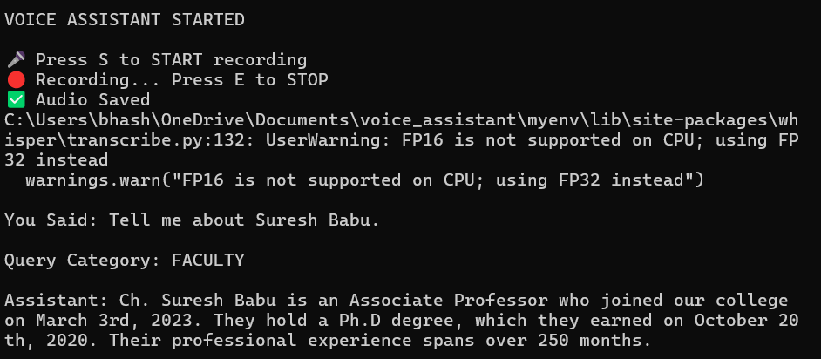

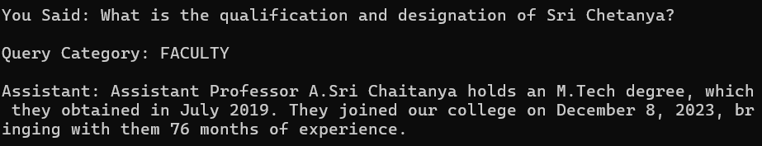

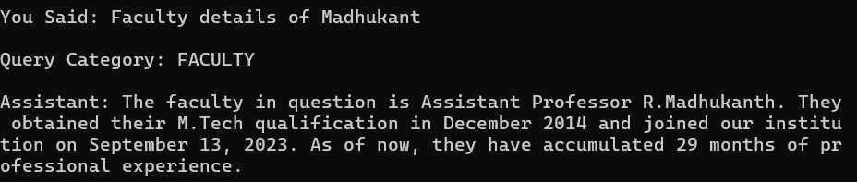

7.4 Timetable Retrieval
Timetable queries retrieve records based on:
- Section
- Day
- Time
- Period
Supported services include:
- Day Timetable
- Section Timetable
- Current Class
- Next Class
- First Class
- Last Class
- Class by Time
- Vacant Rooms
Each service uses a dedicated SQL query to retrieve only the required information.

EXAMPLES:

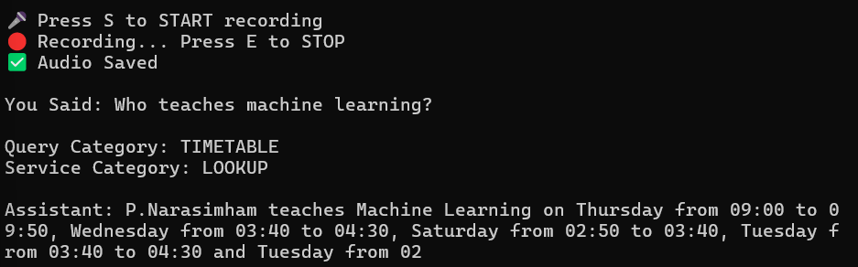

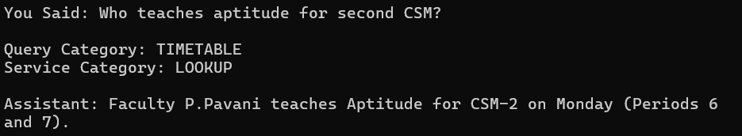

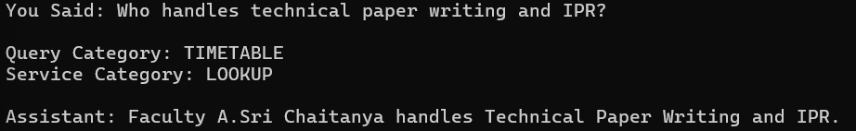
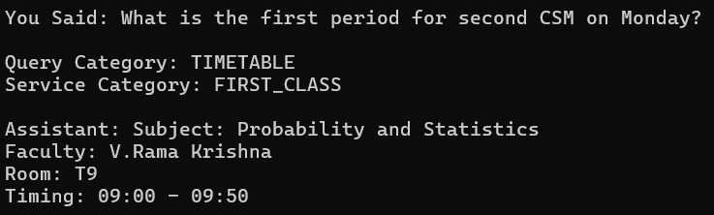

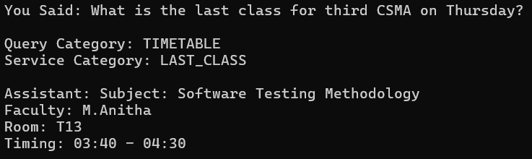

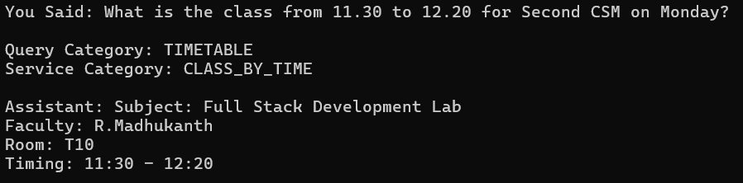

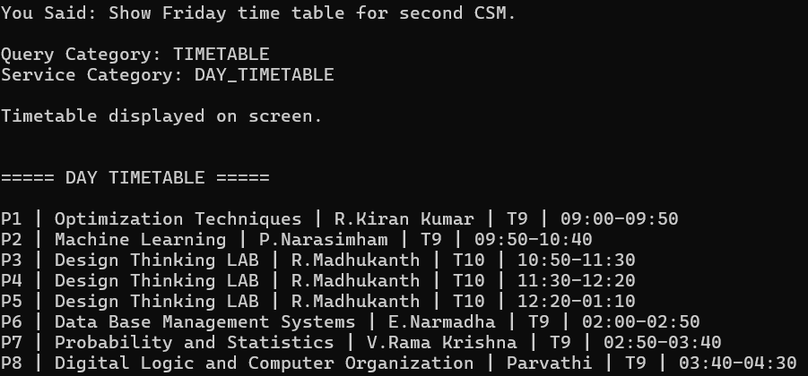

7.5 Response Generation
The retrieved records are passed to the Mistral model through the prompt. Mistral converts the structured data into readable English without changing the actual information.
7.6 Hallucination Reduction
One of the main goals of the project was to reduce incorrect responses generated by the language model.
This was achieved by:
- Retrieving information from PostgreSQL before generation.
- Providing only the retrieved records to Mistral.
- Using strict prompt instructions.
- Preventing the model from using outside knowledge.
- Returning a default message when information is unavailable.
These measures improve the reliability of the responses.

CHAPTER 8
EXECUTION PROCESS
Run the Project
Execute the main application:
python voice_assistant1.py
The assistant starts and waits for voice input.
Expected screen:
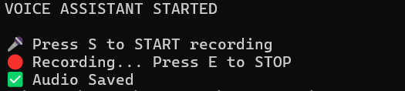

CHAPTER 9
CONCLUSION
The AI-Powered Voice Assistant for Faculty Information and Timetable Retrieval was developed to provide an intelligent and user-friendly way of accessing faculty information and timetable services through voice interaction.
The system successfully integrates:
- Voice input
- Speech recognition using Whisper
- Query and service classification
- PostgreSQL-based data retrieval
- Response generation using the Mistral Large Language Model
- Text-to-Speech output
The modular architecture makes the project easy to understand, maintain, and extend. By combining structured database retrieval with AI-generated responses, the assistant delivers accurate and natural language answers while minimizing hallucinations.
At the current stage, the project successfully supports faculty information retrieval and multiple timetable services, including day timetable, section timetable, current class, next class, first class, last class, class-by-time, and vacant room queries.
Overall, the project demonstrates the practical application of Artificial Intelligence, Natural Language Processing, Large Language Models, and Database Management in developing an interactive voice-based information retrieval system.
Project Status: Ongoing Development with Core Features Completed

